**FRC Team 4918 The Roboctopi**

**2018-2019 Season Business Proposal**



**What is FIRST?**

FIRST is an international program dedicated to exposing students all across the world to robotics. FIRST: *For Inspiration and Recognition of Science and Technology*, the organization strives to give students an opportunity to connect with their community and develop a love for the sciences, through three different competitive robotics tiers. The tiers start with First Lego League, an introductory program that gives students ages nine to sixteen a chance to experience teamwork and FIRST values via a fun game, announced annually, that must be played with a robot built with Lego NXT or EV3 robotic parts. FLL acquaints a student with their community, and begins building teamwork and organizational skills that will last a lifetime. After FLL, there are two options for robotics enthusiasts: First Tech Challenge and First Robotics Competition. Both FTC and FRC give high school age participants the opportunity to enhance their skills and further their interests in Science, Technology, Engineering and Math, as well as construct and program a robot to compete against teams across the nation and the world. As explained on the FIRST website, “The mission of FIRST is to inspire young people to be science and technology leaders, by engaging them in exciting Mentor-based programs that build science, engineering, and technology skills, that inspire innovation, and that foster well-rounded life capabilities including self-confidence, communication, and leadership.”

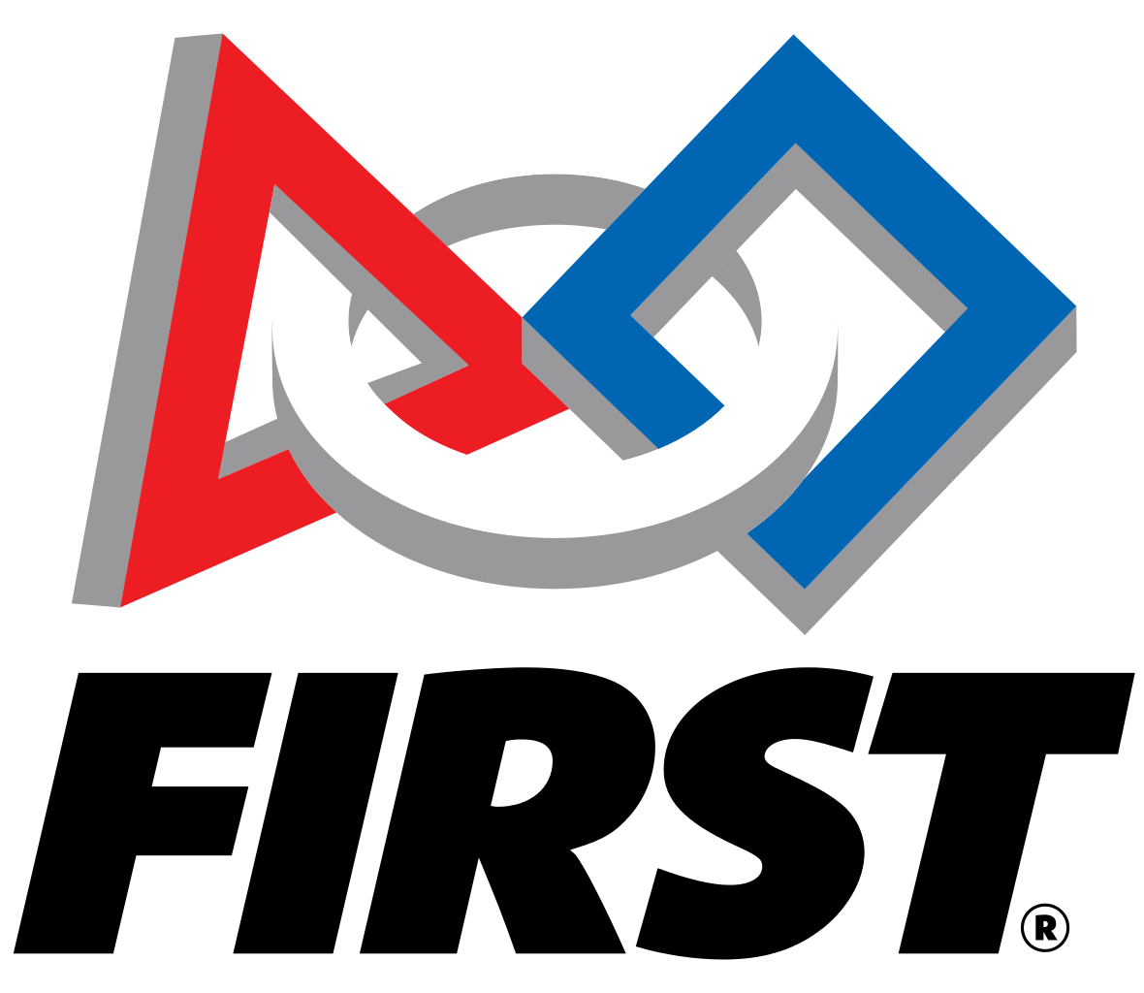

**Who are The Roboctopi?**

FIRST Robotics Competition Team 4918, also known as The Roboctopi, is a FIRST Robotics Team based in Port Townsend, Washington. It was created in 2014 under the mentorship of Austin Henry, an engineer at Atlas Technologies, and in partnership with the Northwest Maritime Center. The rookie team was made up of a core of about a dozen students, most of which would go on to stay with the team until graduating. Returning team members would serve as helpful leaders to newcomers, allowing them to adjust and learn about the complexities of FRC. Over the next few years, the team would go on to win multiple awards, the highest being the honor of attending both the 2015 and the 2017 World Championships, in St. Louis, Missouri and Houston, Texas, respectively. In 2015, a retired Navy avionics engineer, Darrin Newlander, joined the team as a mentor. After several moves, the team eventually settled in a new home at the Port Townsend High School Robotics and Technology Lab, also becoming a 4-H affiliated program and being joined by parent and new mentor Brian Morningstar, a professional entertainment rigger and technical manager.

The Roboctopi hold a philosophy that work should be driven by students. The current two mentors, Austin and Brian, serve mostly to guide, and to assure safety and timeliness occur in all tasks taken on by team members. This approach leads to a learning environment that inspires critical thinking and allows for the fostering of leadership and creativity. Students learn how to build, program, make business plans, and run an organization, all valuable life lessons. Students are exposed to wonderful opportunities as members of a FIRST chapter, such as scholarships, teamwork and Coopertition, a FIRST value, as well as instilling a love for Science, Technology, Engineering and Math.

**2018-2019 Team Roster**

**Mentors**

Austin Henry

Brian Morningstar

Deborah Bakin

**Officers**

Max Morningstar, President

Raphael Bakin, Vice President

Ella Ashford, Treasurer

Olivia Morningstar, Secretary

**Team Members**

Aaron Serrato

Carlos Allen-Avila

Emma Kane

Evan Eades

Gage Barry

Jack Gibbons

Melanie Bakin

Samuel Lott

Tyler Nelson

**Awards and Team Accomplishments**

**2014**

**PNW *FIRST* Robotics Glacier Peak District Event**

Rookie Inspiration Award

**PNW *FIRST* Robotics Mt. Vernon District Event**

Rookie All Star Award

Highest Rookie Seed Award

**2015**

**PNW District – West Valley Event**

Excellence in Engineering Award Sponsored by Delphi

***FIRST* World Championships, St. Louis, MO**

**2017**

**PNW District – Mount Vernon Event**

Innovation in Control Award sponsored by Rockwell Automation

**PNW District – Auburn Event**

District Event Winner

***FIRST* World Championships, Houston, TX**

**2018**

**PNW District – Glacier Peak Event**

Quality Award sponsored by Motorola Solutions Foundation

**Our Budget**

Due to the expense of running a FRC team, and the lack of a major funding partner, the Roboctopi are heavily reliant on fundraising and support from the community. Sponsorship allows our team to act to its fullest potential, and one of the reasons we identified for not being as successful in years past was a lack or strategy and organization when it came to fundraising. This year, we are reaching out to donors for help in building up our program to provide life changing experiences to both current and future members, creating the next generations of engineers and programmers. Additionally, all donations are tax deductible and are handled through Washington FIRST. Below is our sample budget, constructed out of numbers from both past years and multiple other documents from other FRC teams.

|  |  |
| --- | --- |
| **EXPENSES** |  |
|  |  |
| **Essential Costs** |  |
| Registration Fees and Kit of Parts | $10,886 |
| Robot Building Materials (Competition) | $8,500 |
| Robot Building Materials (Rookie) | $1,000 |
| Tools | $500 |
| Practice Field/Game Elements | $500 |
| **Subtotal** | **$16,386** |
| **Promotion and Outreach** |  |
| Team Uniforms | $400 |
| Buttons/Handouts/Banner | $500 |
| Fundraising Materials | $300 |
| **Subtotal** | **$1,200** |
| **Travel** |  |
| Qualifier #1 | $2,000 |
| Qualifier #2 | $2,000 |
| Regionals | $3,000 |
| **Subtotal** | **$7,000** |
|  |  |
| **Miscellaneous** | **$500** |
|  |  |
| **TOTAL EXPENSES (without Worlds)** | **$30,086** |
|  |  |
|  |  |
| Expenses for World Championships - Houston, TX | +$20,000 |
| **TOTAL EXPENSES (with Worlds)** | **$50,086** |

**Levels of Sponsorship**

By sponsoring the FRC Team 4918, The Roboctopi, sponsors receive the following benefits depending on the amount of money, labor or materials donated:

**Superior Cephalopod** *$2500 or more*

Benefits:

* Prominent logo on Robot
* Name on Team Uniforms
* Prominent logo on Team Banner
* Logo/Name on Sponsor Page

**Heroic Humboldt** *$1000 - $2499*

Benefits:

* Small Logo/Name on Robot
* Name on Team Uniforms
* Prominent logo on Team Banner
* Logo/Name on Sponsor Page

**Outstanding Octopus** *$500 - $999*

Benefits:

* Name on Team Uniforms
* Small name/logo on Team Banner
* Logo/Name on Sponsor Page

**Noteworthy Nautilus** *$250 - $499*

Benefits:

* Small name/logo on Team Banner
* Logo/Name on Sponsor Page

**Contributing Cuttlefish** *$100 - $249*

Benefits:

* Logo on Sponsor Page

**Supportive Squid** *$50 - $99*

Benefits:

* Name on Sponsor Page

*FRC Team 4918 is qualified through FIRST Washington for tax exemption under section 501(c)3 of the Internal Revenue Code. EIN is 45-2443839.*

**Thank You to Our 2017-2018 Sponsors:**

|  |  |  |
| --- | --- | --- |
| Washington State OSPI | Kane Enterprises | Leidos |
| Edensaw Woods, LTD | Allen Brown STEAM Foundation | Boeing |
| Port Townsend Foundry | Kearson, Morningstar & Associates, Inc | Matilda Henry |
| Andeavor (formerly Tesoro) | Turn Point Design | David Miller |
| First Washington FRC Grant | Peninsula Flooring | Lee’s Les Schwab |
| Dog House Powder Coating | Anderson Machine Shop | Jefferson Healthcare |
| Intellectual Ventures | Arrow Lumber | Protogate |
|  | Henery Hardware |  |

**And “Thank You!” to Our 2018-2019 Sponsors:**

Washington State OSPI

Boeing

Leidos

Olympic Art and Office Supply

Kiwanis of Port Townsend

Quimper Mercantile Company

Octopus Gardens

The Commander’s Beach House B&B

**Benefits of Sponsorship**

The Roboctopi are eager to seek out and receive any form of donation that will assist the team in continuing their advancement in FRC, and will go to any length to represent and advertise a sponsor. In addition to allowing students to have the amazing opportunities that come with being on a FRC team, sponsoring The Roboctopi is both tax deductable and can also have a positive impact within your own organization:

**Increase Publicity and Visibility**

* Advertisement at every FIRST event attended to by The Roboctopi
* Acknowledgement in all major releases or publications by The Roboctopi
* International exposure if The Roboctopi are able to advance beyond the District finals

**Create Educational Opportunities for Students**

* Engineering and business concepts are introduced to students
* Problem solving skills are greatly expanded through hands-on interaction
* Planning and organization become permanent facets of a team members life long after graduation from the team
* Social skills from interacting with hundreds of fellow FRC members
* Millions of dollars in scholarships opportunities through FIRST
* Students get to foster a love for STEM in an environment that encourages free thinking and development of a student’s interest in engineering

**Boost Organization Morale**

* Renewed inspiration for organization members
* Strengthens and informs local communities of your organization and its reputation
* Offers members immense pride to sponsor The Roboctopi

**More Information**

For more information or if you have any questions, please look at our website at frc4918.github.io/webpage/ or contact one of the team’s mentors:

**Brian Morningstar** [brianmstar@earthlink.net](mailto:brianmstar@earthlink.net)

**Austin Henry** [austinh054@gmail.com](mailto:austinh054@gmail.com)